**BIT706 Programming 3 Assessment 2 Christopher Tipper**

**Task 1 Design a controller class:**

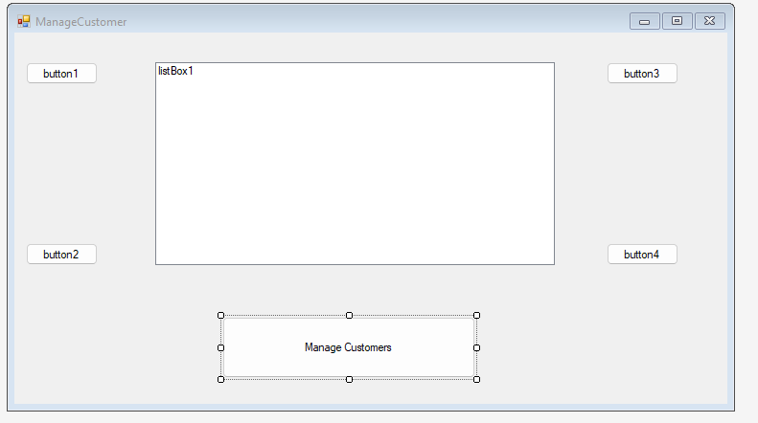

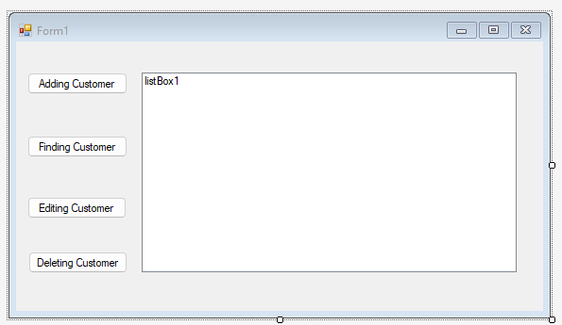

The design has met the requirements of managing the customers information by having the features to add, edit, find, and delete the customer(s). The main form has the features for managing the customers. This form will allow to have different user interfaces by having the features added on to them such as changing details for the banks, saving the customer details and for the main users to be able to see it, and searching for general details which are not too personal.